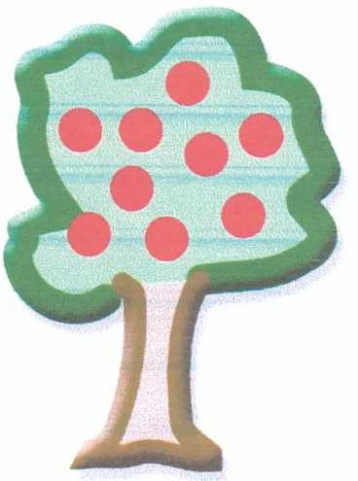 Park Nursery Medicine & Calpol Policy.

Park Nursery can administer all medications prescribed by a Doctor; we follow guidelines set out in the Statutory Framework for the Early Years Foundation Stage, a Government document, this is available upon request.
Practitioners within the setting are all Paediatric First Aid trained, but staff are not nurses/doctors.
All medicines can only be given with prior consent from Parents/Carers, this is upon arrival at Nursery and is signed for to administer the correct dosage/time, also we will need the time when the last dose was given, upon collection of your child a signature is required in acknowledgment of medication given to your child.
Calpol which has NOT been prescribed by a Doctor can be given to your child ONCE a day, and no more than 3 consecutive days, it is suggested that a child who needs Calpol twice a day may have underlying problems/illnesses, we will ask and need to know the reason for the Calpol to have been given, after an hour of giving the Calpol if your child still appears to be unwell, or their temperature has not gone down then we will be contacting you to collect your child. For a child whose temperature is not going down, Calpol will only mask this, temperatures that exceed 39*c will be classed as a medical emergency, as a child is at risk of convulsions.
If the child has had a high temperature and appears unwell, the policy is that the child stays at home for the next 24 hrs.
All staff are aware of the Policy, and will always refer to a Senior Practitioner if they have any concerns/worries, your child’s welfare/care is paramount whilst in the Nursery environment.
If a child suffers from Febrile Convulsions then a Healthcare plan will be put in place, this will enable calpol to be administered if necessary, and be reviewed regularly with the parents to make sure the plan meets the needs of the child.
BONJELA/TEETHING CRYSTALS - After recent news articles about the side effects of these products we will need you to sign the Medicine Form for us to administer them to your child, stating when needed/times last given etc just like our Medicine Policy that we currently follow, so please let us know when dropping off if your child requires it, thankyou.

*Diarrhoea & Sickness – as you are aware this can “fly” round a setting and be very upsetting for the children, we do require your child to remain away from Nursery 48 hrs AFTER the last episode of either, please adhere to this as it is the only way it can be eradicated from the setting, as you do not want your child to become ill, or pick it up again !....we have a thorough hygiene process to prevent as many ailments but we do need your support in all matters. Thankyou.
Please can you sign the slip below and return to Nursery to say you understand the policy and will adhere to it, thankyou again for your support.
……………………………………………………………………………………………………………………………………………………………………………………………
Calpol & Medicine Policy.
Child’s Name…………………………………………………………………………. I have read & fully understand the policy
……………………….…………………………………………………………………………..……………………………(parents name & signature)
This policy has been devised and shared with all the team at Park Nursery on 15.3.19
Manager, Claire Nichol

